**Assignment # 2, 3**



**2020**

**CSE102 Computer Programming Lab**

Submitted to:

**Engr. Athar Javed Sethi**

Submitted by:

**TAYYABA**

Registration No **:**

**19PWCSE1854**

Semester: **2nd**

Class Section: **C**

“On my honor, as student of University of Engineering and Technology, I have

neither given nor received unauthorized assistance on this academic work.”

Student Signature: ______________

March 2nd, 2020

**Department of Computer Systems Engineering**

**University of Engineering and Technology, Peshawar**

**Bubble Sorting :**

#include<iostream>>

using namespace std;

int main()

{

int a[50],n,i,j,temp;

cout<<"Enter the size of array: ";

cin>>n;

cout<<"Enter the array elements: ";

for(i=0;i<n;++i)

cin>>a[i];

for(i=1;i<n;++i)

{

for(j=0;j<(n-i);++j)

if(a[j]>a[j+1])

{

temp=a[j];

a[j]=a[j+1];

a[j+1]=temp;

}

}

cout<<"Array after bubble sort:";

for(i=0;i<n;++i)

cout<<" "<<a[i];

return 0;

}

**Output:**

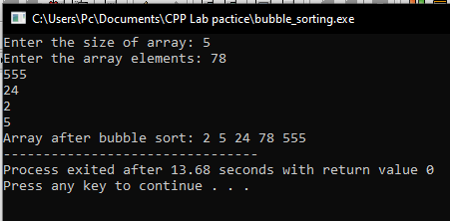

**Selection Sorting:**

#include<iostream>

using namespace std;

int main()

{

int i,j,n,loc,temp,min,a[30];

cout<<"Enter the number of elements:";

cin>>n;

cout<<"\nEnter the elements\n";

for(i=0;i<n;i++)

{

cin>>a[i];

}

for(i=0;i<n-1;i++)

{

min=a[i];

loc=i;

for(j=i+1;j<n;j++)

{

if(min>a[j])

{

min=a[j];

loc=j;

}

}

temp=a[i];

a[i]=a[loc];

a[loc]=temp;

}

cout<<"\nSorted list is as follows\n";

for(i=0;i<n;i++)

{

cout<<a[i]<<" ";

}

return 0;

}

**Output:**

